**Motherboards**

**XT Motherboards**:

XT Stands for eXtended Technology. These are all old model motherboard. In this motherboards, we find old model processor socket LIF (Low Insertion Force) sockets, ram slots Dimms and ISA (Industry Standards Architecture) slots, 12pin Power Connector and no ports.

They have slot type processors, Dimms memory modules, ISA slots for add-on card, and no ports. There are connectors and add-on cards for ports.

Eg: Pentium-I, Pentium-MMX, Pentium -II and Pentium-II Processors.

[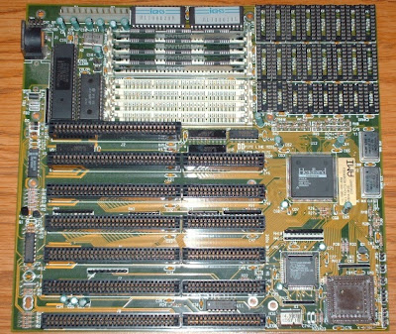](http://4.bp.blogspot.com/-Vx-5LEsSG_M/UAebqnsvrMI/AAAAAAAAAGQ/exkzj2pOre0/s1600/xt+motherboards.jpg)

**AT Motherboards**:

AT stands for Advanced Technology. Advanced Technology Motherboards have PGA (Pin Grid Array) Socket, SD Ram slots, 20pin power connector PCI slots and ISA slots. we find the above components on AT motherboards.

Eg: Pentium-III Processors

[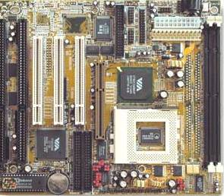](http://2.bp.blogspot.com/-B4hlTaxP9zA/UAec18aWNWI/AAAAAAAAAGY/Coe-tYNwO08/s1600/at.jpg)

**Baby AT Motherboards**:

Baby AT Motherboards have the combination of XT and AT. They have both slot type processor sockets and PGA processor sockets, SD Ram slots and DDR Ram slots, PCI slots and ISA slots, 12 Pin power connector and 20Pin power connector and Ports.

Eg: Pentium-III and Pentium-IV

[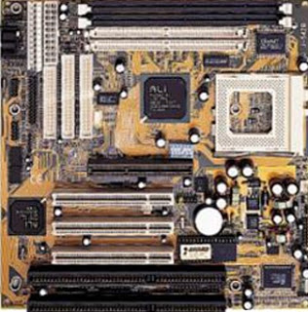](http://4.bp.blogspot.com/-uqyGfoE2yS8/UAeeHudRNwI/AAAAAAAAAGg/vz8Tlp7S0dc/s1600/baby+at.JPG)

**ATX Motherboards**:

ATX stands for Advanced Technology eXtended. latest motherboards all are called as ATX motherboards. designed by ATX form factor. In this motherboards, we find MPGA Processor Sockets, DDR Ram slots, PCI slots, AGP slots, Primary and secondary IDE interfaces, SATA connectors, 20pin and 24 pin ATX power connector and Ports.

Eg: Pentium-IV, Dual Core, Core 2 Duo, Quad Core, i3, i5 and i7 Processors.

[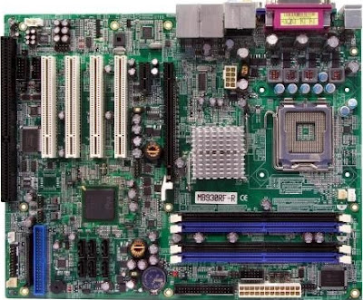](http://1.bp.blogspot.com/-xHM1V73K_uQ/UAehBdhEPWI/AAAAAAAAAGs/GBtuJIO-7gw/s1600/atx.jpg)